The Tommy Nunez National Hispanic Basketball Classic has been sponsoring an annual men’s tournament since 1980. The NHBC is hosted by North and Central High School of the Phoenix Union High School District. Their support has played a vital role in the success of our tournaments and we offer our most sincere thanks.

The NHBC’s goal is to raise money to help defray expenses of youth academic and athletic activities for the economically disadvantaged and those youth considered “at-risk” and has done so for almost 30 years.

The Tommy Nuñez Foundation Scholarship and Youth Activities Foundation is a 501(c)3 non-profit certified foundation.

The IRS Tax ID number is:
86-0557854.

The Tommy Nuñez 10th Annual Charity Golf Tournament

The purpose of this event is to bring some of my closest friends and sponsors together for a day of fun, laughs and a little golf. I hope that you can find the time to join me.

ASU’s Karsten Golf Course
1125 E. Rio Salado Parkway
Tempe, AZ

$100.00 per person entry fee includes:

- Golf, cart and range balls
- Catered lunch
- Polo golf shirt

Please return registration with check made payable to:

Tommy Nuñez Foundation
6120 W. Park Avenue
Chandler, AZ 85226

For more information, contact

Tommy Nunez at 480-389-8342

Donnie Nunez at 480-251-1005 donnienunez@cox.net

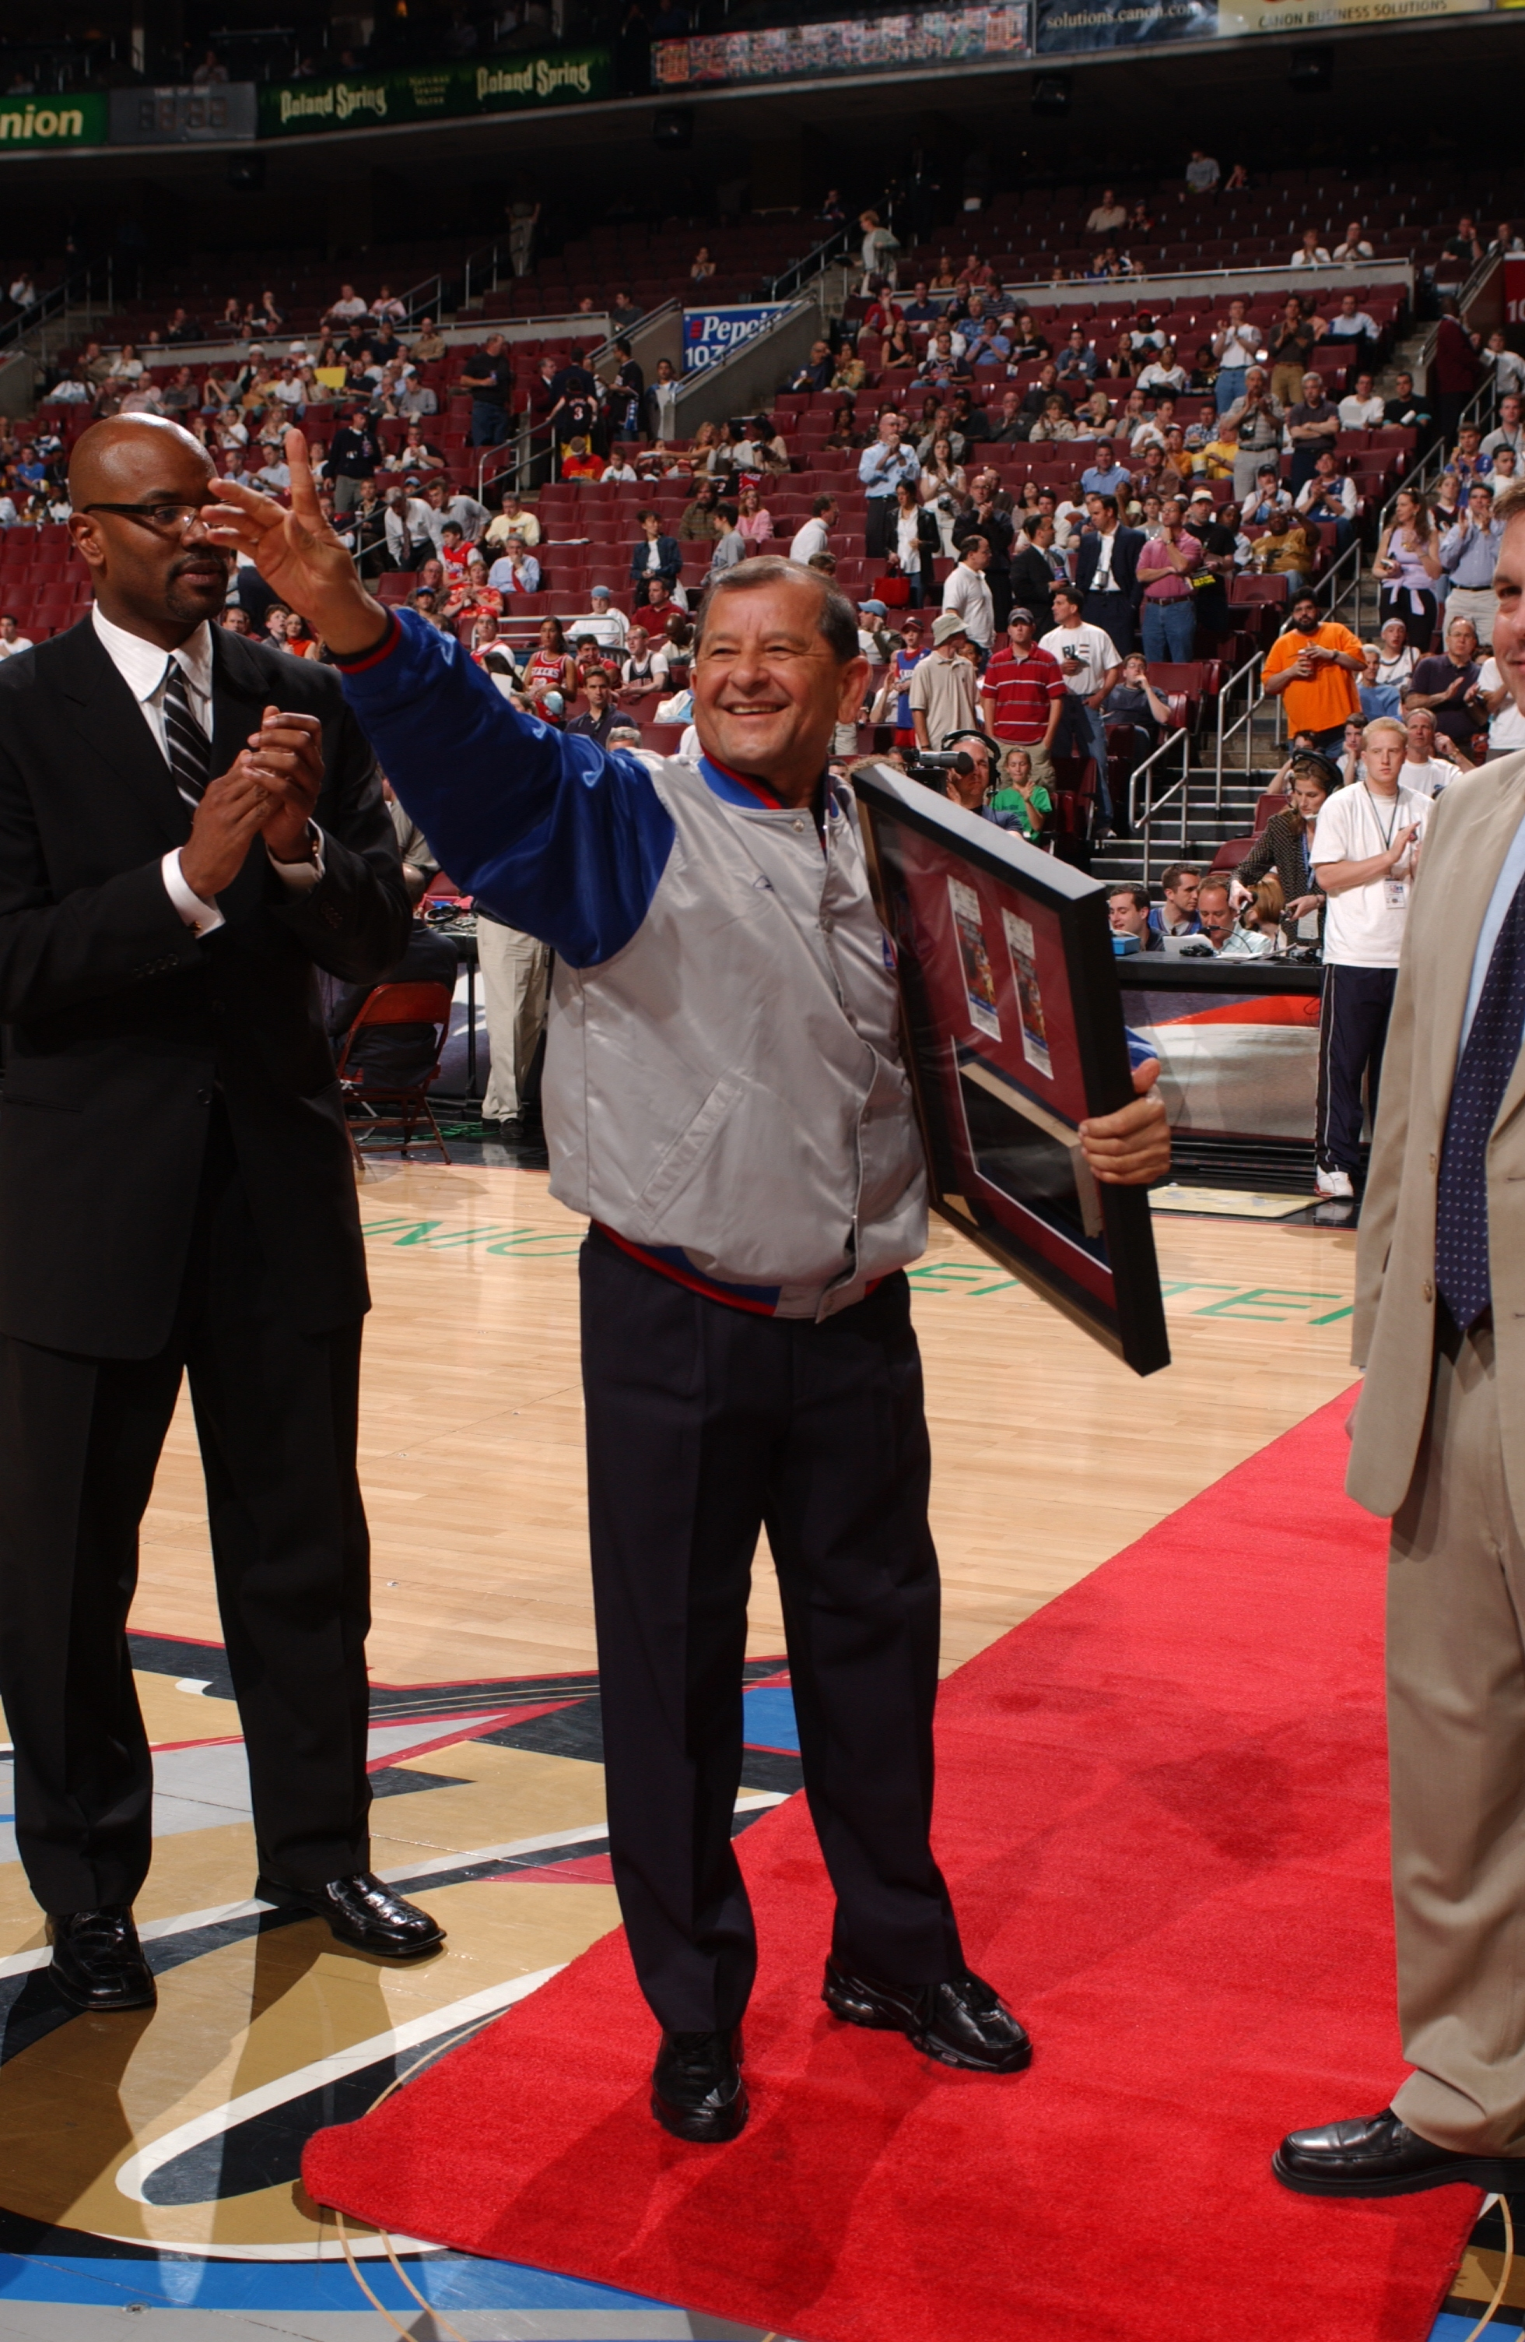

The Tommy Nuñez
Scholarship and Youth Activities Foundation

presents

The Tommy Nuñez Charity Golf Tournament

Saturday - June 13th, 2009

My friends,

As founder and sponsor of the National Hispanic Basketball Classic, I am personally involved with the fight to lower the drop out rate and to help youth overcome the many social problems they face. My “Academics through Athletics” campaign is my commitment to serve youth based on my belief that they should be given every opportunity to succeed in life.

All proceeds from this annual event are intended for the NHBC’s objectives of educating youth about the dangers of using drugs and/or dropping out of school. I will work to continue to enlighten the youth through clinics, presentations and by supporting academic and athletic activities. In addition, twenty-five College or trade school scholarships will be awarded to deserving youth for the upcoming school year.

Please join me so that we can all do our small share to ensure these kids continue to have the opportunity to pursue higher education.

Sincerely,

Tommy Nuñez
NHBC Director
Schedule of events, tournament format and prizes:
___________________________________________

6:30 AM – Registration

7:30 AM – Shotgun start

12:30 PM – Catered lunch

1:00 PM – Acknowledgements

1:15 PM – Raffle and Auction

- Four person scramble

- Longest drive hole

- Longest putt hole

- 4 Closest to the pin holes

- Hole-in-one prizes on all par 3 holes include cars, golf clubs and trips

- Individual awards to 1st, 2nd, 3rd and last places

- Many valuable raffle items to choose from
_________________________
Golf Team members

- _____________________

- _____________________

- _____________________

- _____________________

**Contact name and phone number
____________________________________________________________

Amigos,

I have many highlights in my life, but helping kids help themselves is one of my biggest thrills. I would like to take a moment to thank all of you who have supported me over the years. Without my friends and sponsors, none of the successes my events have had, would have ever been possible. Additionally, I would like to thank Budweiser for their willingness to always lend a hand to help with my events.

Thanks again…Tommy



